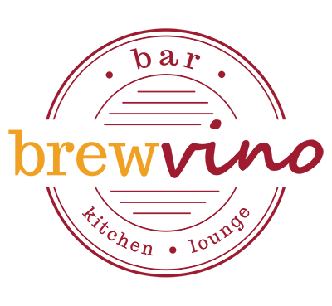

**2 course lunch & drink – Only $49**

**small plates**

choose from

pumpkin dip, olive oil, grilled sourdough

slow cooked pork belly bites, black caramel, asian slaw

Salt & pepper squid, aioli

tempura tofu, miso eggplant, pickled shimeji mushrooms, wakame, kewpie

**main plates**

choose from

squid salad

beef or chicken burger, chips

pan fried gnocchi

fish & chips, salad

**drinks**

choose from

glass of house shiraz, cab sav, semillon sauvignon blanc or sparkling wine

schooner of Coopers Draught

spritz cocktail – lemon, strawberry or pineapple

***add a dessert for $10***